**Task on EC2:**

**1.Launch one EC2 using Amazon Linux 2 image and add a script in user data to install Apache.**

**Go to EC2 → Instances → Launch instance.**

**Keep the default Security Group**

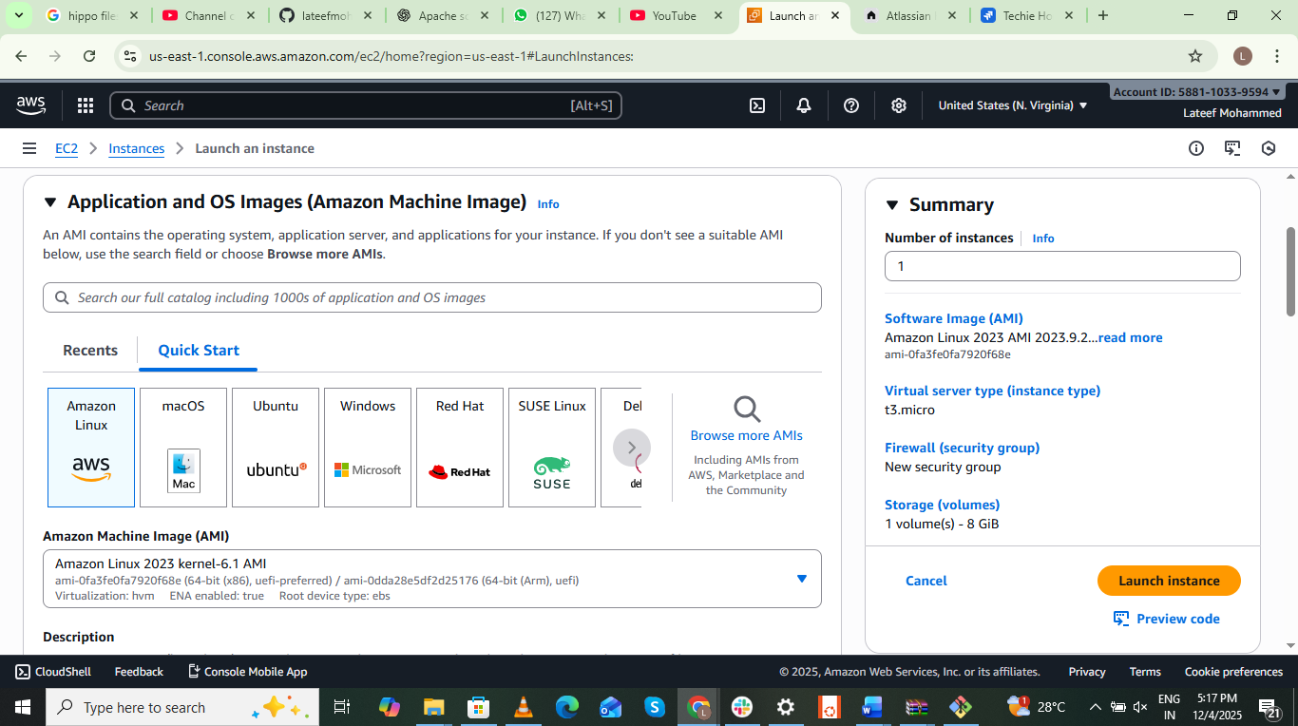

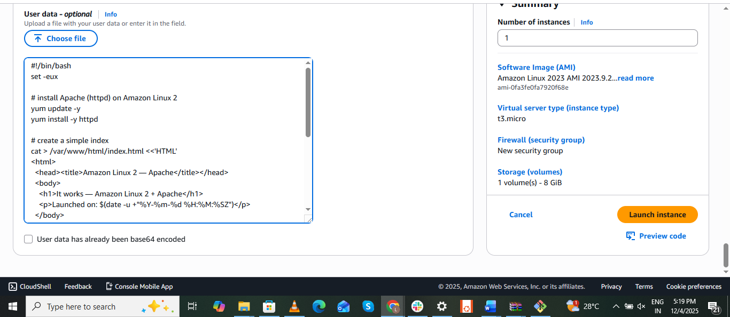

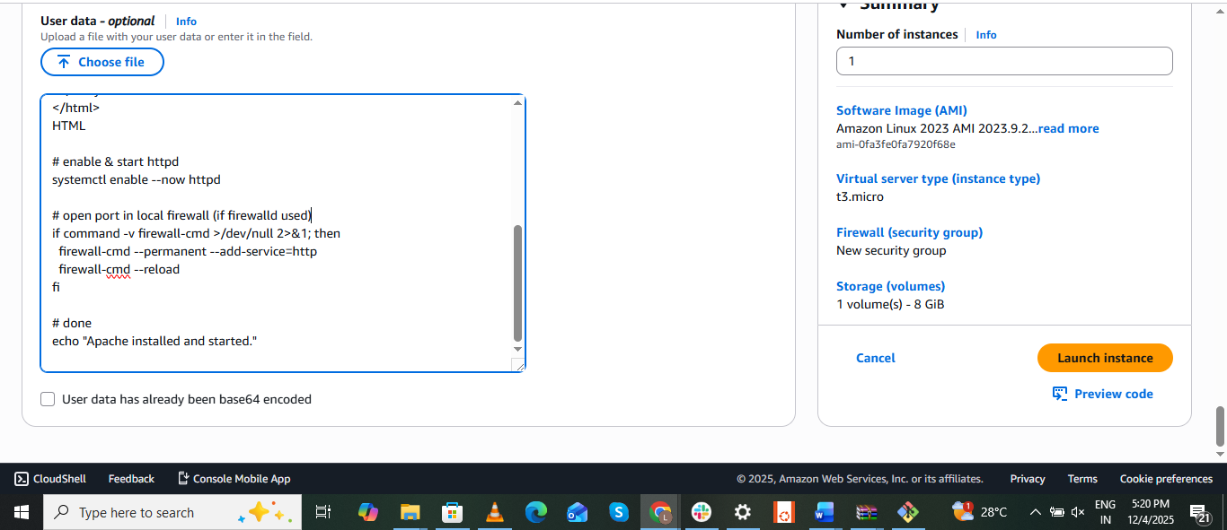

Check status by using sudo systemctl status command

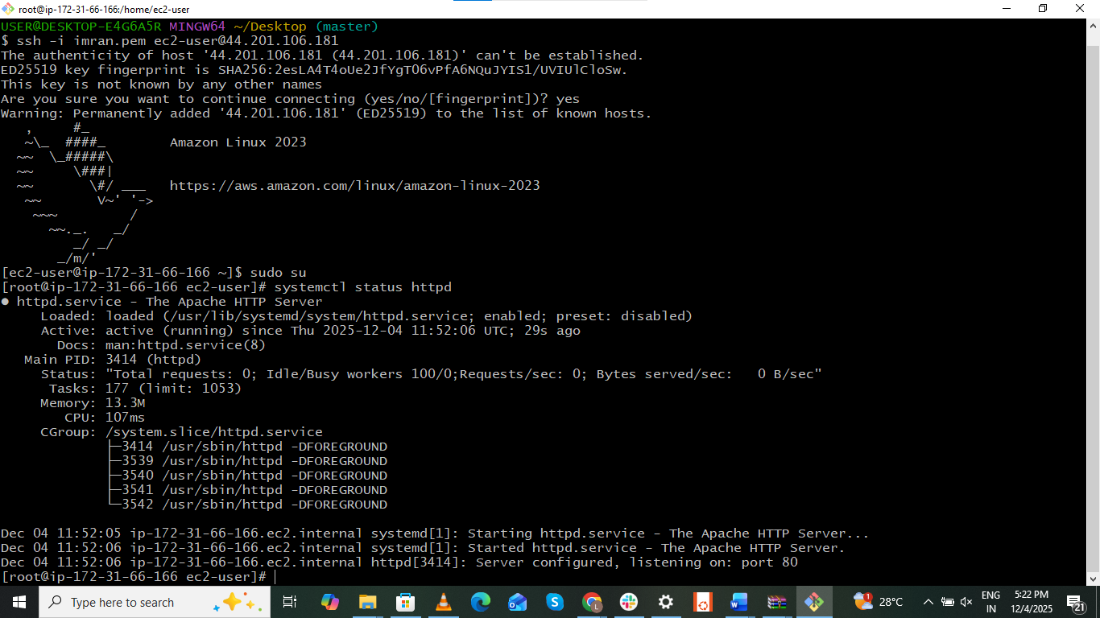

**2.Launch one EC2 using Ubuntu image and add a script in user data to install Nginx.**

EC2 = A computer in AWS

Ubuntu = Operating system

User Data = A note that tells computer what to do when it starts

Script installs **Nginx**, the web server that shows a page

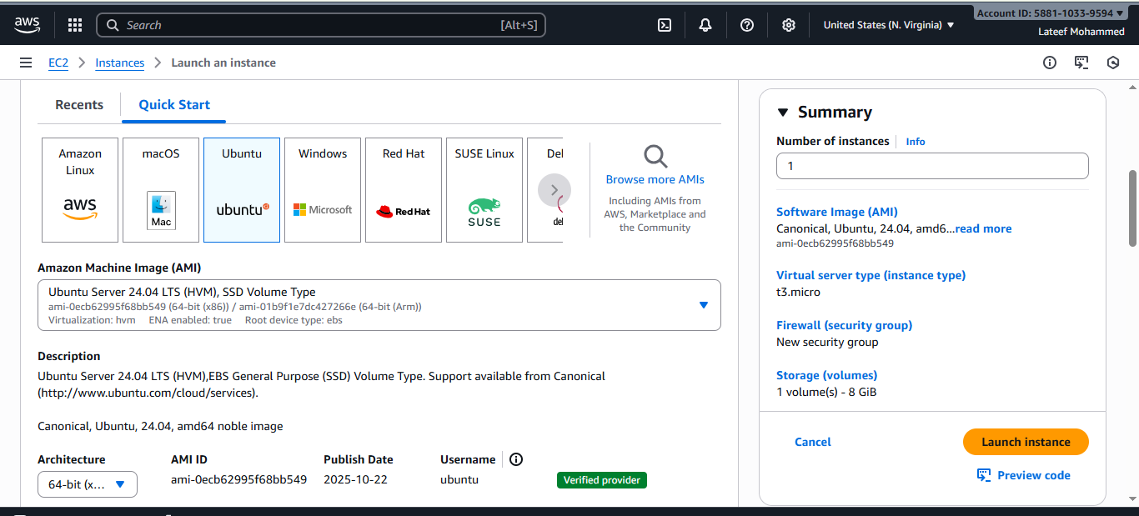

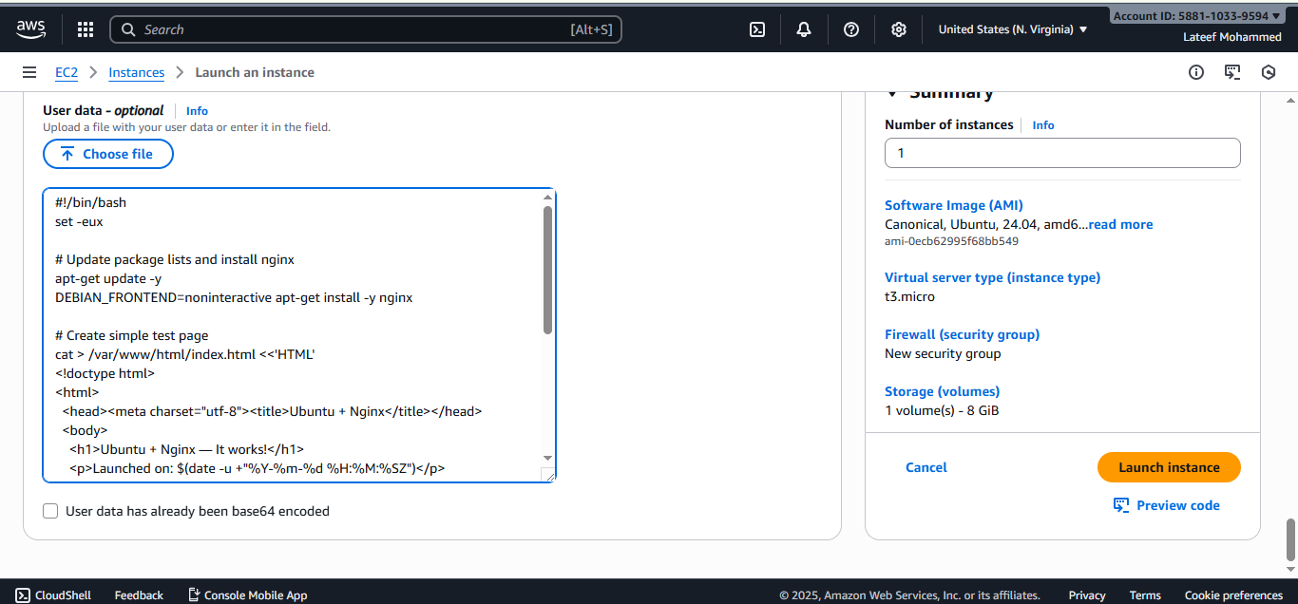

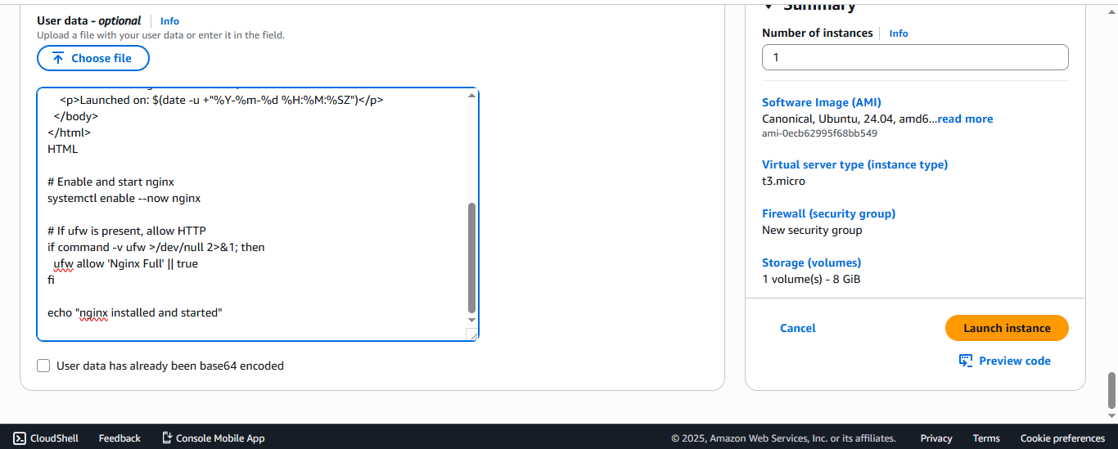

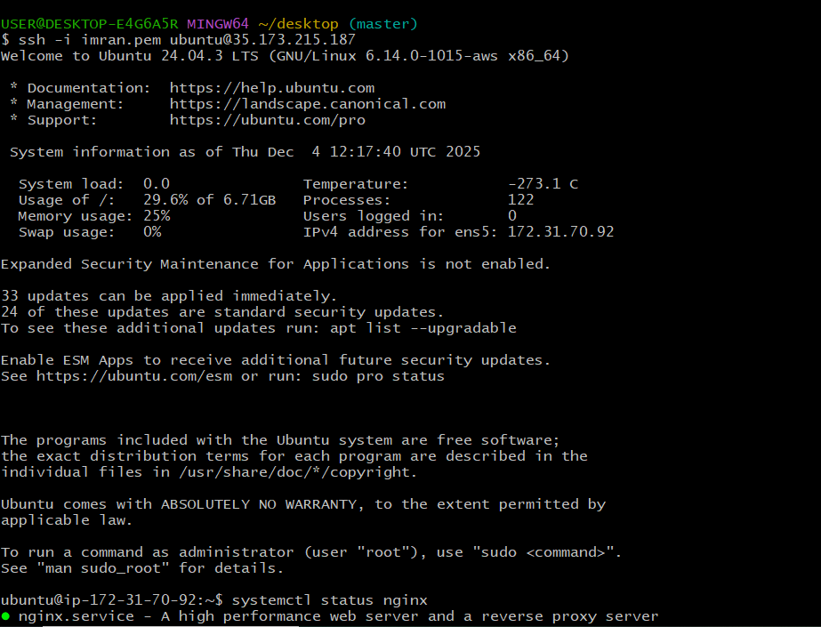

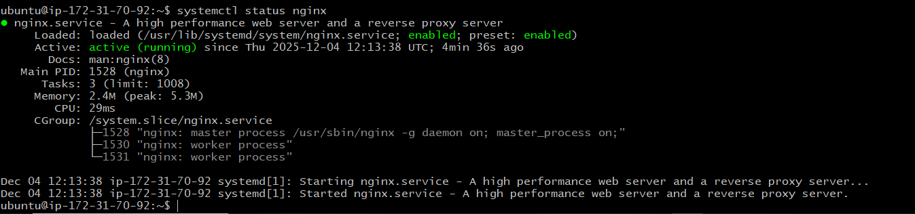

**3.Launch one Windows server and install Tomcat on Windows:**

**Launch the EC2 Instance**

Go to **AWS Console → EC2 → Instances → Launch Instance**

Name your instance EC2 SERVER Windows-Tomcat-Server

**Username:** Administrator

**Password:** (the decrypted one)

Create a new key pair or use an existing one

Download .pem file

Next, click on **Get Password**

Add **RDP (port 3389)** rule for your IP

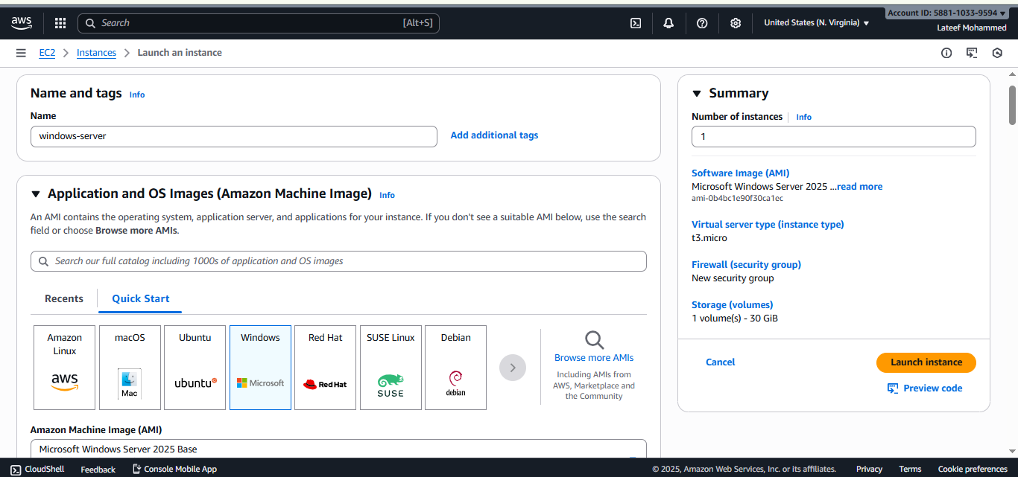

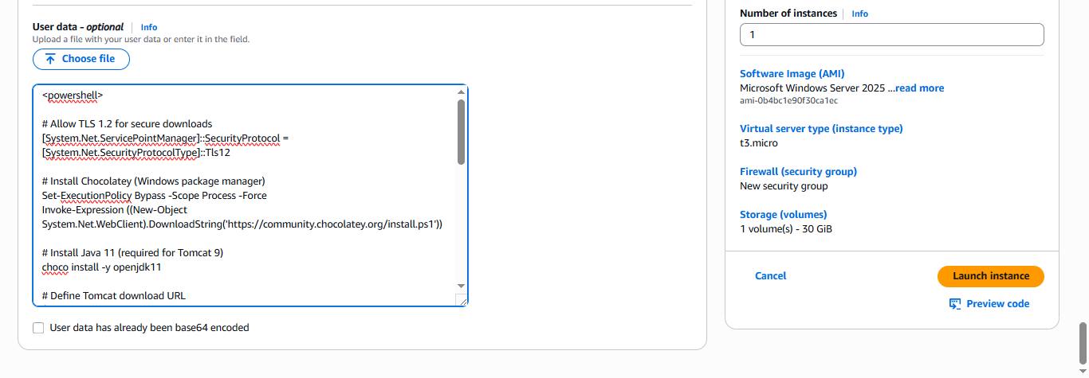

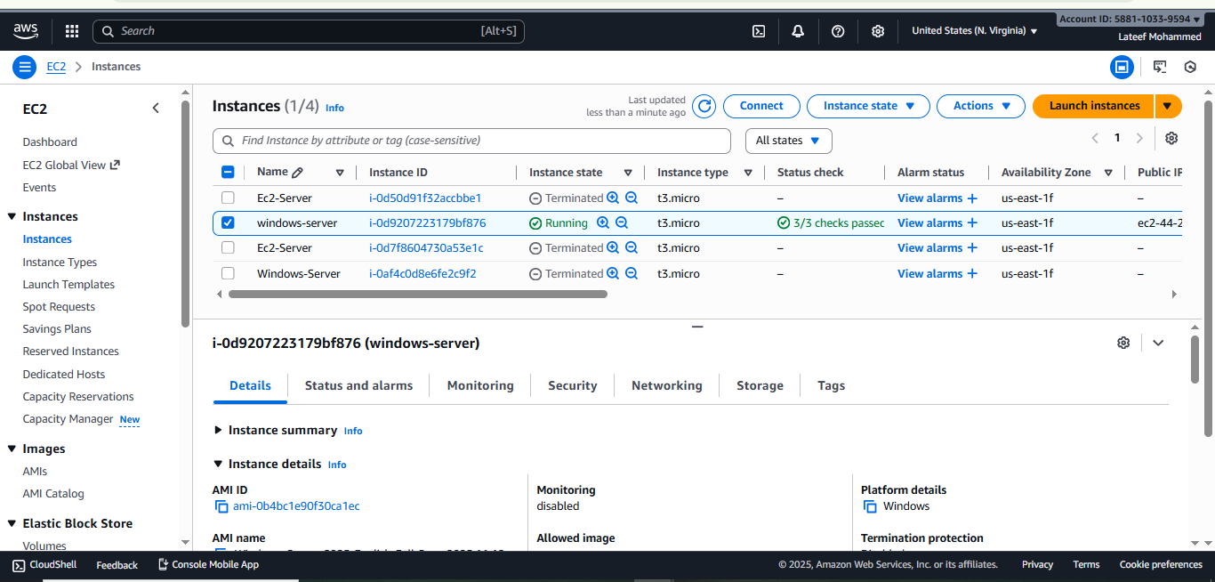

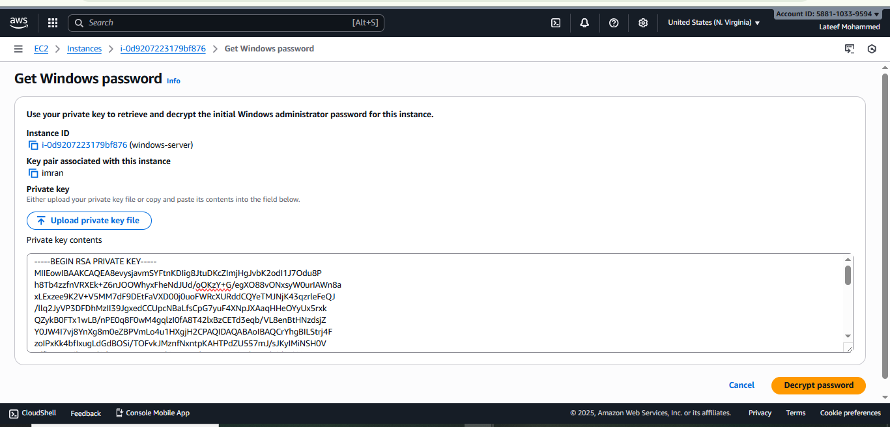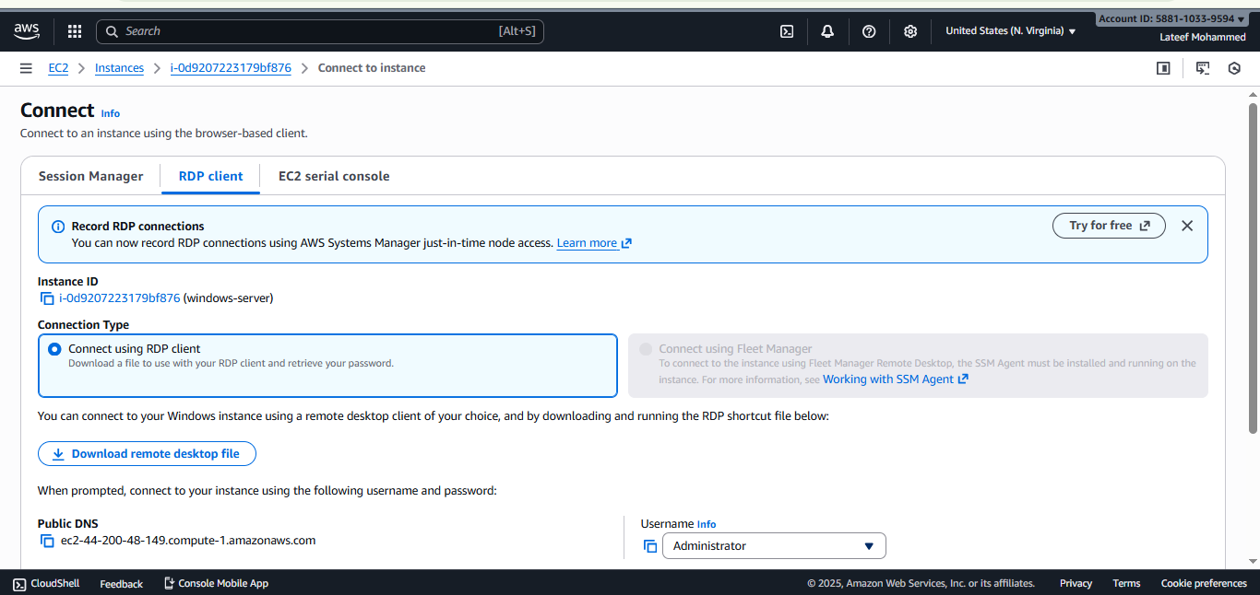



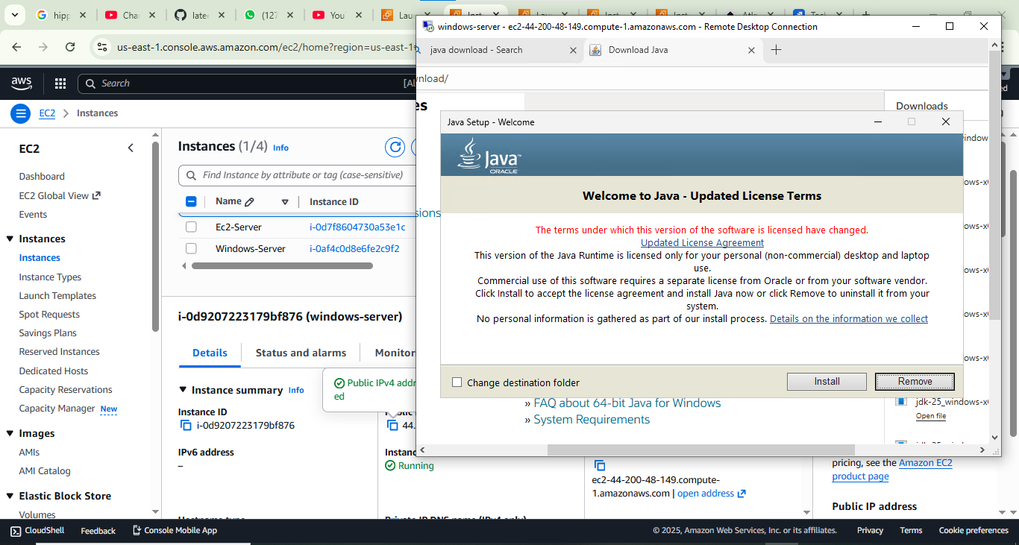

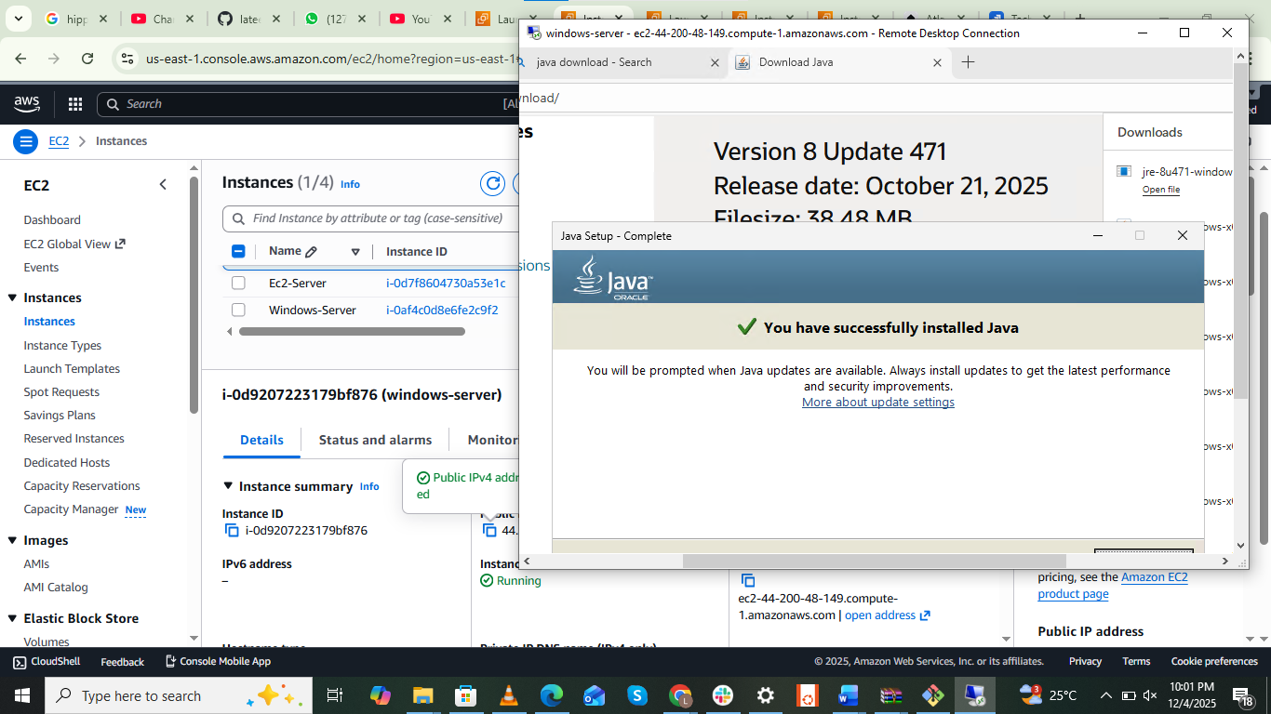

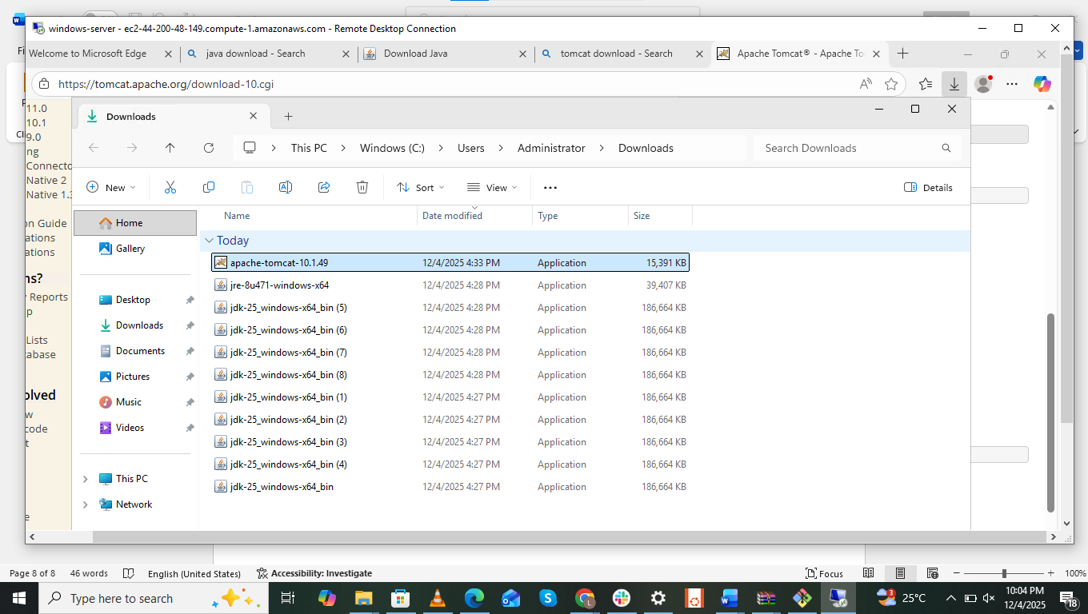

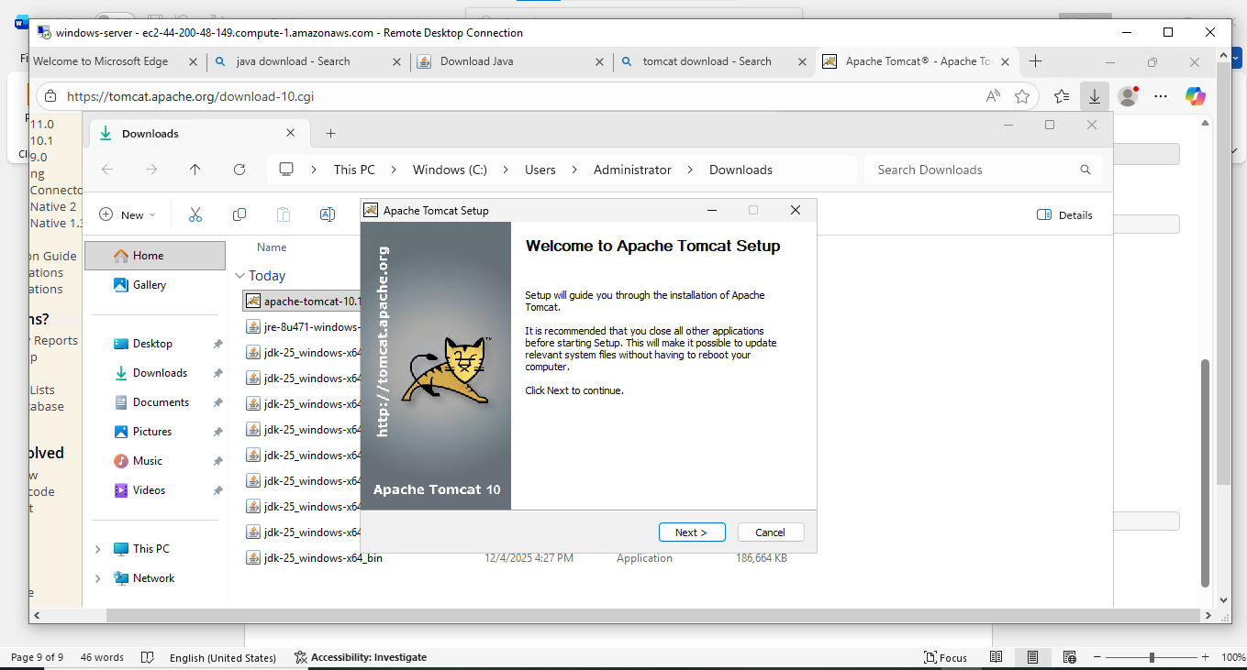

**4.Take a snapshot of the instance created in Task 1:**

AWS Management Console and go to the **EC2 dashboard**.

navigation pane, click **Instances**.

instance selected, click the **Actions** dropdown menu.

Navigate to **Image and templates**, then select **Create image**.

**Image name** and a helpful **Image description** (e.g., "Snapshot for EC2 instance created in Task 2").

**stop the instance** before creating the image.

To do this, leave the "No reboot" option unchecked

Click **Create image**.

**5.Assign password less authentication for the EC2 created in Task:**

First check if you already have an SSH key.

**6.Launch any EC2 using the spot purchasing option:**

**Go to ec2 dashboard and in spot instance options select no maximum price**

**Give default security groups and key pair**

**Launch the instance in lifecycle details you will see spot**

**7.Enable termination policy on the EC2 created in Task 2:**

**Go to EC2 Dashboard → Instances.**

**Select your Task 2 EC2 instance.**

**Click on Actions → Instance Settings → Change Termination Protection.**

**Check “Enable” and click Save.**

**Now, the instance cannot be accidentally terminated.**

**8.Launch one EC2 using AWS CLI:**